31.27: a) At the resonance frequency, 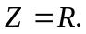
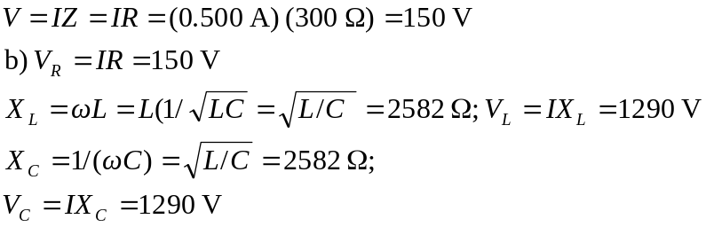
c)
